FIRST MILESTONE

**Team Id:** PNT2022TMID54147

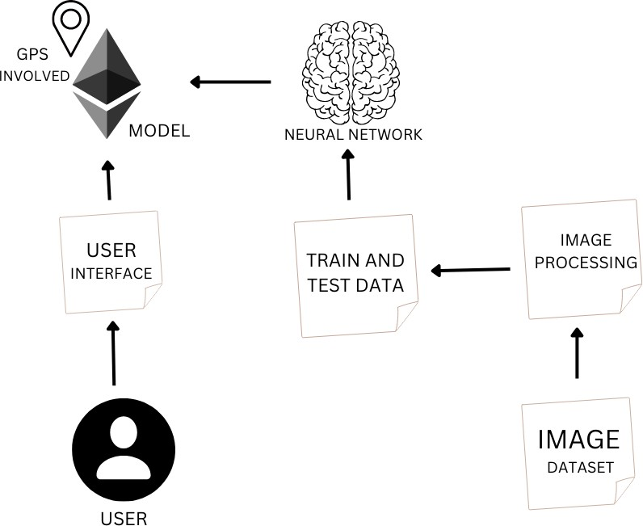

PROJECT THEME:

* By implementing this project we get a clear knowledge of neural networks.
* This project is based on image processing and voice recognition.
* Firstly should train a dataset and test dataset are uploaded in the image set.
* Whenever the user require to recognized the data in front of them, the object is detected at particular distance.
* Then they are sensed by the user interface thus get transferred to the project model to be sensed.
* Then the data is compared with the dataset in the convolutional neural networks.
* Then required output is given in vocal form to the user.